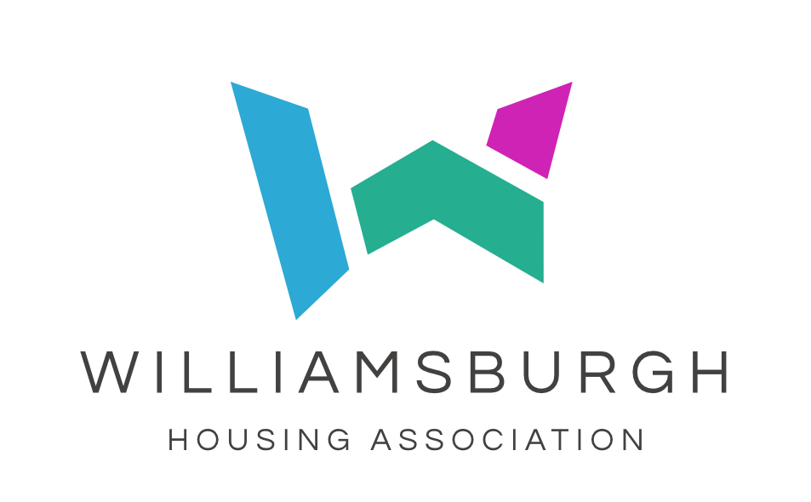

Annual Lettings Plan 2024 - 2025

- Introduction

Williamsburgh Housing Association is a locally-based provider of quality, affordable, rented housing in areas throughout Renfrewshire.

We are committed to providing housing for those in housing need, offering choice, while also considering the best use of our properties, in relation to promoting balanced and stable communities in the areas in which we operate.

- Aims and Objectives

The Association operates a Common Allocations Policy that aims to provide housing for those in housing need, offering choice, while also considering the best use of our properties, in relation to promoting balanced and stable communities in the areas in which we operate. We will provide fair and open access to our housing list and assessment process, ensuring:

• the efficient allocation of properties as they
become available,
• that the number of empty properties is kept
to a minimum,
• that void rent loss is contained within our target of 0.8%

Our Lettings Plan outlines the allocation Group to which our available properties should be relet.

- Housing Stock

Our housing stock of 1,677 units is located throughout Paisley East, North and West, in addition to Johnstone, Renfrew and Kilbarchan. It contains properties built to amenity and wheelchair standard, as well as general needs.
- Allocations Policy

Our Allocations Policy is a common one, shared by partners in Renfrewshire including Renfrewshire Council. It prioritises and groups housing applications in the same way in order that applicants will have their applications for housing treated equally, regardless of who they apply to for housing. This should also aid any information and advice given to applicants in relation to seeking housing from any of the partner housing providers.

Applications for housing are assessed in accordance with our Allocations Policy, and placed in their respective queues. Homeless applications received through Section 5 referrals however, are assessed by Renfrewshire Council and matched to void properties offered by us to the Council. There is therefore, no queue for Section 5 referral applicants.

- Relets in 2023-2024

Based upon the targets set for the year 2023-2024, the following was achieved;

Target Lets 2022/23 | Target Achieved | Target
Group 1 (Homeless) | 40.83% | 40%
Group 1 (Nominations) | 3.33% | 10%
Group 2 (Mobility including transfers) | 8.33% | 8%
Group 3 (General Housing List) | 26.67% | 25%
Group 4 (Transfer - non mobility) | 7.5% | 12%
Group 5 (No housing need) | 0.83% | 5%
Referrals | 0.83% | 0%
Management Transfer | 3.33% | 0%
Ukraine Refugee | 8.33% | 0%
Grand Total | 100.00% | 100%

Allocations to Group 1 applicants are made by us offering void properties to Renfrewshire Council. They then identify a suitable applicant who is either a homeless section 5 referral, or a nominated applicant, who is then selected to view the property. We are delighted to have achieved this target and helped homeless people.

Although during 2023-2024 we had a target of 8% for Group 2, mobility, allocations within this group are determined by the turnover of properties built to either wheelchair or ground floor amenity standard. Contained within the number of lets made to this group are existing WHA tenants who required rehousing for mobility reasons.

We have only just exceeded our target of 25% for Group 3, general needs. In previous years we have been unable to meet our homeless target which in turn meant that we let more to our Group 3 – general needs. By achieving our homeless target this year, our lets to general needs – 26.67%, is more aligned with our target.

Targets are not set for management transfers, agency referrals or lease arrangements as they fall outwith the regular Group system, and are based on needs that arise, and existing agreements that are in place with external agencies.

- Turnover

The tables below provide details of our turnover since 2009.

Year | No of tenancies given up
2009 | 131
2010 | 152
2011 | 128
2012 | 169
2013 | 184
2014 | 180
2015 | 170
2016 | 175
2017 | 168
2018 | 107
2019 | 156
2020 | 147
2021 | 114
2022 | 117
2023 | 139
2024 | 105

- Targets for 2024-2025

When setting our allocation targets for 2024-2025 we have considered the following:

- Our existing arrangement with Renfrewshire Council of 40% net lets for Section 5 referrals and 10% for nominations.

- The demand for wheelchair and mobility standard accommodation (Group 2) from both applicants and existing WHA tenants.

- Demand for internal transfers and our desire to successfully meet the targets set previously.

- Allocations achieved during 2023-2024.

- Wheelchair and amenity standard properties are automatically passed to Group 2 mobility.

- Demand for accommodation.

- Turnover of void properties –105 during 2023-2024.

- It is not anticipated that decant accommodation will be required.

- Where existing lease agreements are in place and due for renewal during 2024-2025, they have not been included in target allocations.

Target Allocations 2023-2024
Homeless  Section 5 referrals (40%)  Nominations (10%)  Target  50% | Mobility  (direct applications and WHA transfers)  Target  8% | Housing need (direct housing applications)  Target  25% | Transfers (non- mobility)  Target 12% | Transfer  (no housing need)  Target  5%

